PSEB AI ENGINEERING BOOTCAMP • ASSIGNMENT 01
Cricket Ticket Booking System
Module: Python Programming • Practical Assignment Submission Report
Trainee Name: | Ameer Hamza | Trainee ID: | TRN-2026-001056
Programme: | Artificial Intelligence | Stream: | AI
Cohort: | PSEB-AI-LHR-01 | Status: | Enrolled
Lead Trainer: | Bilal Nadeem | Venue: | Online

1. Assignment Overview & Objectives
This project implements an interactive, menu-driven Cricket Stadium Ticket Booking System in Python. The application simulates real-time stadium seat reservations while strictly adhering to fundamental programming principles without relying on complex classes, external packages, or dictionaries.
- Core Data Structure: Two-dimensional Python list holding seat number, category name, and booking status.
- Search & Update Algorithm: Linear loop traversal for seat verification and in-place status modification ('Available' -> 'Sold').
- Integrity Checks: Comprehensive validation preventing duplicate bookings and handling non-existent seat inputs.
- Analytics & Metrics: Real-time tracking of remaining tickets and dynamic computation of total tickets, sold seats, and percentage capacity sold.
2. Functional Tasks Breakdown
Task | Description | Implemented Behavior
Task 1: Display All Tickets | View complete stadium inventory | Traverses 2D list and displays Seat Number, Seat Name, and Status in aligned tabular format.
Task 2: Book a Ticket | Purchase ticket with validation | Searches seat by number, updates status in-place to 'Sold', prevents duplicate bookings, rejects invalid seats.
Task 3: Display Available | Filter available inventory | Iterates with conditional filter to display exclusively seats marked as 'Available'.
Task 4: Display Sold | Filter booked inventory | Iterates to display only seats marked as 'Sold' alongside their seat categories.
Task 5: Remaining Tickets | Capacity analytics (Bonus included) | Counts available vs. sold seats and calculates overall percentage of tickets sold.
3. Complete Python Source Code (.py)
Below is the complete, self-contained Python source code from ticket_booking_system.py. You may review or replace this section directly.
# ==============================================================================
# Cricket Ticket Booking System
# Python Programming Assignment - 1
# ==============================================================================

# 1. Initial Ticket Data (Stored in a 2D Python List)
# Each record contains: [Seat Number, Seat Name, Status]
tickets = [
[101, "VIP", "Available"],
[102, "VIP", "Available"],
[103, "General", "Available"],
[104, "General", "Available"],
[105, "Premium", "Available"],
[106, "Premium", "Available"],
[107, "General", "Available"],
[108, "VIP", "Available"]
]

# 2. Main Menu-Driven Program
while True:
print("\n=================================")
print(" CRICKET TICKET SYSTEM ")
print("=================================")
print("1. Display All Tickets")
print("2. Book a Ticket")
print("3. Display Available Tickets")
print("4. Display Sold Tickets")
print("5. Remaining Tickets")
print("6. Exit")

choice = input("\nEnter your choice: ").strip()

# Task 1: Display All Tickets
if choice == "1":
print("\n--- All Stadium Tickets ---")
print(f"{'Seat Number':<15}{'Seat Name':<15}{'Status':<15}")
print("-" * 45)
for ticket in tickets:
print(f"{ticket[0]:<15}{ticket[1]:<15}{ticket[2]:<15}")

# Task 2: Book a Ticket
elif choice == "2":
seat_input = input("\nEnter seat number: ").strip()

# Check if the user entered a valid integer
if not seat_input.isdigit():
print("Invalid input! Please enter a valid numeric seat number.")
else:
seat_number = int(seat_input)
found = False

# Linear search through the list
for ticket in tickets:
if ticket[0] == seat_number:
found = True
if ticket[2] == "Available":
ticket[2] = "Sold" # Update status directly in the list
print("\nTicket Booked Successfully!")
print(f"Seat Number: {ticket[0]}")
print(f"Seat Name: {ticket[1]}")
print(f"Status: {ticket[2]}")
else:
print("\nSorry! This ticket has already been sold.")
break # Stop search once match is found

if not found:
print(f"\nSeat number {seat_number} does not exist. Please check the seat number.")

# Task 3: Display Available Tickets
elif choice == "3":
print("\n--- Available Tickets ---")
print(f"{'Seat Number':<15}{'Seat Name':<15}{'Status':<15}")
print("-" * 45)
available_found = False
for ticket in tickets:
if ticket[2] == "Available":
print(f"{ticket[0]:<15}{ticket[1]:<15}{ticket[2]:<15}")
available_found = True
if not available_found:
print("No tickets available. All seats are sold out!")

# Task 4: Display Sold Tickets
elif choice == "4":
print("\n--- Sold Tickets ---")
print(f"{'Seat Number':<15}{'Seat Category':<15}")
print("-" * 30)
sold_found = False
for ticket in tickets:
if ticket[2] == "Sold":
print(f"{ticket[0]:<15}{ticket[1]:<15}")
sold_found = True
if not sold_found:
print("No tickets have been sold yet.")

# Task 5: Calculate Remaining Tickets (Includes Bonus stats)
elif choice == "5":
total_tickets = 0
sold_tickets = 0
available_tickets = 0

# Loop through list to count based on conditions
for ticket in tickets:
total_tickets += 1
if ticket[2] == "Sold":
sold_tickets += 1
elif ticket[2] == "Available":
available_tickets += 1

print("\n--- Remaining Tickets Summary ---")
print(f"Total Tickets: {total_tickets}")
print(f"Sold Tickets: {sold_tickets}")
print(f"Available Tickets: {available_tickets}")

# Bonus: Percentage of tickets sold
if total_tickets > 0:
percentage_sold = (sold_tickets / total_tickets) * 100
print(f"Percentage Sold: {percentage_sold:.1f}%")

# Exit Program
elif choice == "6":
print("\nThank you for using the Cricket Ticket System. Goodbye!\n")
break

# Invalid menu selection
else:
print("\nInvalid option! Please enter a number from 1 to 6.")

4. Test Cases & Execution Screenshots
In accordance with submission requirements, below are the designated test scenarios demonstrating successful booking, duplicate booking prevention, category filtering, and remaining capacity calculation.
Test Case 1: Initial State & Successful Ticket Booking
• Operation: Display all tickets (Option 1), then book available seat number 103 (Option 2).
• Expected Result: Status of seat 103 updates in-place to 'Sold' with confirmation details.
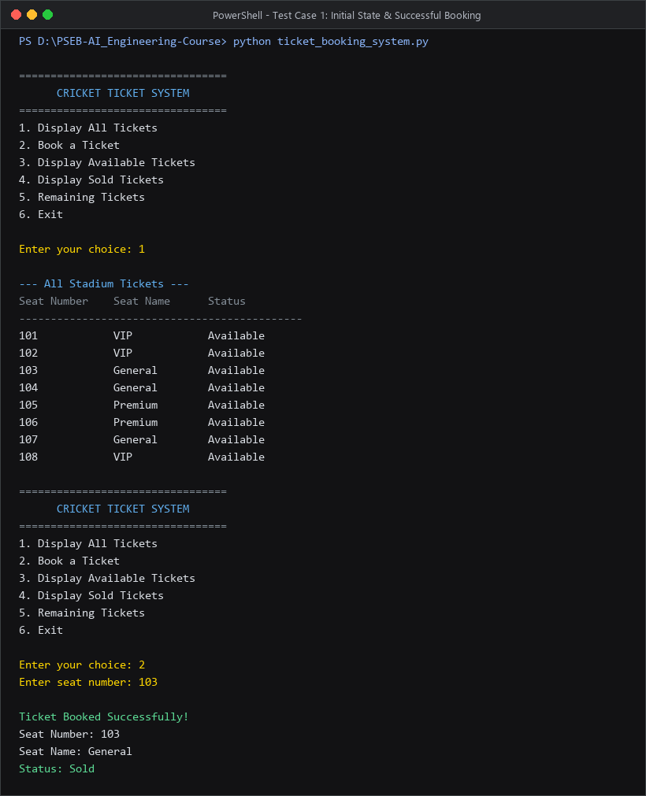

Test Case 2: Prevention of Duplicate Booking
• Operation: Attempting to purchase seat number 103 a second time (Option 2).
• Expected Result: System rejects booking and displays 'Sorry! This ticket has already been sold.'
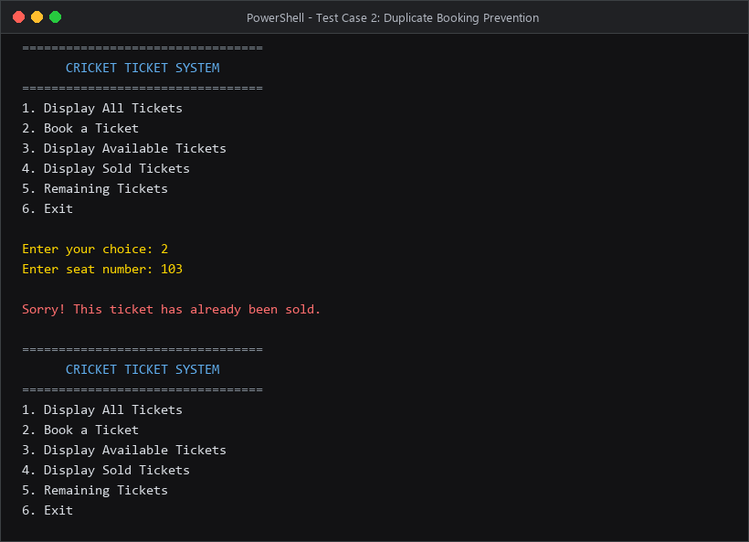
Test Case 3: Invalid Seat Number & Input Handling
• Operation: Entering an invalid or non-existent seat number (e.g. 999).
• Expected Result: System outputs an error stating the seat does not exist.
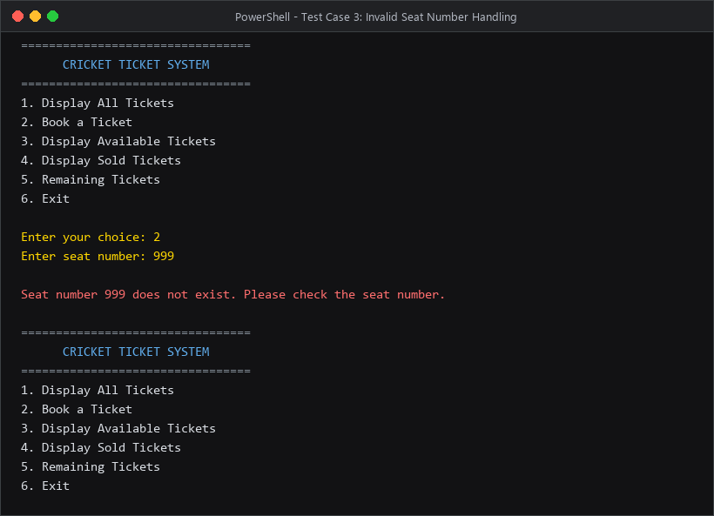

Test Case 4: Category Filtering & Remaining Capacity Summary (Bonus)
• Operation: Display Available Tickets (Option 3), Sold Tickets (Option 4), and Remaining Tickets (Option 5).
• Expected Result: Displays accurate available/sold counts and percentage of capacity sold.


